# **RL Project 3**

I have trained the network for 30,000 iterations and following are the results I got.

I tried changing the number of convolution layers and the linear layers, but I observed that we need more convolution layers because our input are images.

The model I chose was the most optimal one and since I did not get much time to train, I’m presenting my results only for 30K iterations.

The mean score observed was 2.74 over 100 episodes.

The model is as follows.

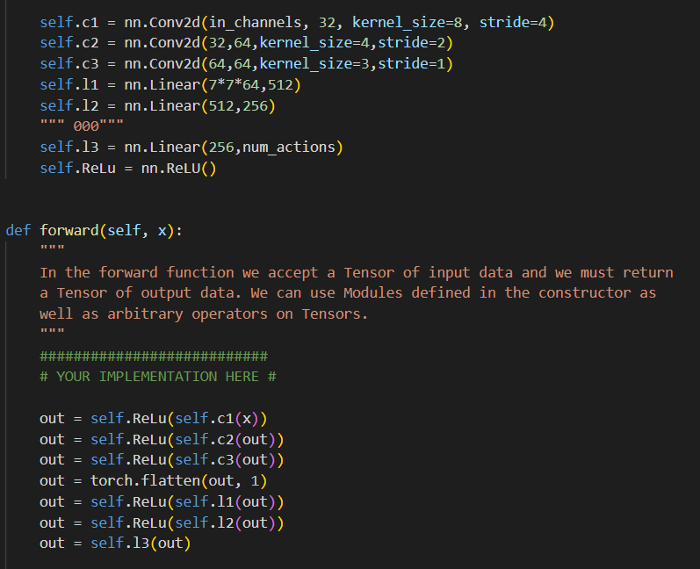

I regret to say this, but I could not get the optimal results due to the lack of training time. But the model is saved as DQN.pth in the folder.

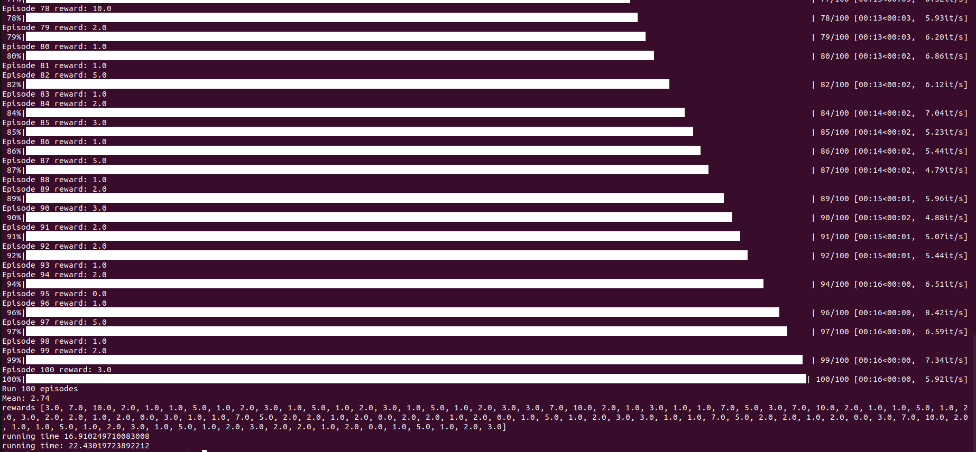

The test image is as follows:

